This Application Cover Form must be included with entry to be eligible for judging
District entry due Feb. 1st /Awarded at District Arts Festival

General Federation of Women’s Clubs of North Carolina
General Clubwoman of the Year Award Entry Form
(Please copy for future use)
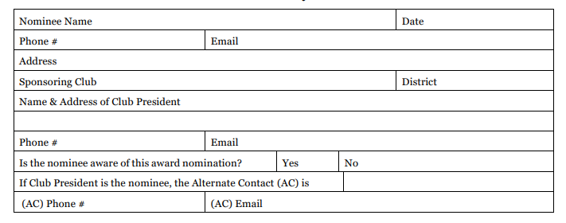

Minnie Lou Parker Creech Wine Cooler -The award is given annually to honor a General clubwoman who has given of her time, talents, interest, organizational efforts, and active participation to render outstanding service through the Federation. The judging criteria is based on accomplishments during the previous year, January 1 to December 31. This award is first judged on the District level.

Rules for Participation:
- The nominee shall not be entered in any other GFWC-NC Individual Award Contest in the same year.
- This entry must be typewritten and adhere to the following minimum requirements: 8.5” x 11” size document; single spaced; 10pt font; 1” margins; and no more than (4) pages, with one being the completed Award Entry Form.
- A copy of the entry must be sent by the club president to the District President, unless otherwise directed, postmarked no later than February 1.
- The District President or District Awards Chairman will have these judged by three competent clubwomen who live outside and preferably not adjacent to the district for which they serve as judges. (The three judges for selection of the GFWC-NC winner should be those serving as current or past presidents of other state organizations in North Carolina and/or Past Presidents or Directors of Juniors of GFWC-NC or of other states within GFWC; with at least one being a member of the GFWC-NC)
- The District award will be presented at the District Arts Festival. Following the District Arts Meeting, the District winning award entry will be emailed or postmarked to the current GFWC-NC President-Elect timestamped no later than 11:59pm on March 1st.
- Past winners of this award on the GFWC-NC level shall not be eligible to win the same award again.

Criteria (Note: Nominees will be judged only on the information you furnish):
Judging criteria will be based on activities for the previous calendar year only. Submit in detail the achievements and the nature of service of your candidate, noting the qualification of your nominee and keeping in mind that the judging will be based on the following items:
Contribution through Federation: 30-GFWC-NC, 25-District, 25 Local | 80 Points
Participation in Community Affairs (church, political, other service organizations,  civic, board positions, etc. | 10 Points
Cooperation with individuals and other club members | 10 Points
TOTAL | 100 Points

