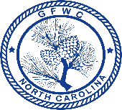
This Award Entry Form must be included with entry to be eligible for judging
District entry due Feb. 1st /Awarded at District Arts Festival

General Federation of Women’s Clubs of North Carolina
Outstanding Citizenship and Patriotism Award Entry Form
(Please copy for future use)
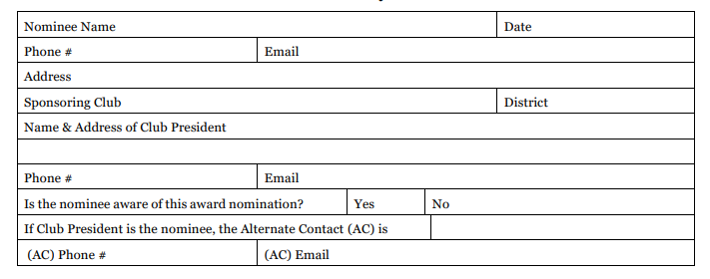

Bryant Citizenship Bowl, Juanita Martin Bryant, donor. The award is to recognize a clubwoman (General or Junior) for outstanding work in citizenship and patriotism. The award is given annually, and the judging criteria is based on accomplishments during the previous year, January 1 to December 31. This award is first judged on the District level.

Rules for Participation
- The nominee shall not be entered in any other GFWC-NC Individual Award Contest in the same year.
- This entry must be typewritten and adhere to the following minimum requirements: 8.5” * 11” size document; single spaced; 10pt font; 1” margins; and no more than (4) pages, with one being the completed Award Entry Form.
- A copy of the entry must be sent by the club president to the District President, unless otherwise directed, postmarked no later than February 1.
- The District President or District Awards Chairman will have these judged, and the district award will be made at the District Arts Festival. Following the District Arts Meeting, the district winning award entry will be emailed or postmarked to the GFWC-NC Recording Secretary timestamped no later than 11:59pm on March 1st.
- This entry shall be judged by three (3) individuals with at least one of them being an active clubwoman.
- Past winners of this award on the State level shall not be eligible to win the same award again.

Criteria (Note: Nominees will be judged only on the information you furnish):
Judging criteria will be based on activities for the previous calendar year only. Submit in detail the achievements and the nature of service of your candidate, noting the qualifications of your nominee and keeping in mind that the judging will be based on the following items:

Outstanding contributions in citizenship, patriotism, and community affairs including church, political, other service organizations, civic, board positions, etc. | 75 Points
Contribution through Federation: (5)-State, (5)-District, (5)-Local | 15 Points
Cooperation with individuals | 10 Points
TOTAL | 100 Points

